*Curriculum Vitæ*

# Personal information

Name **Nishant Jana**

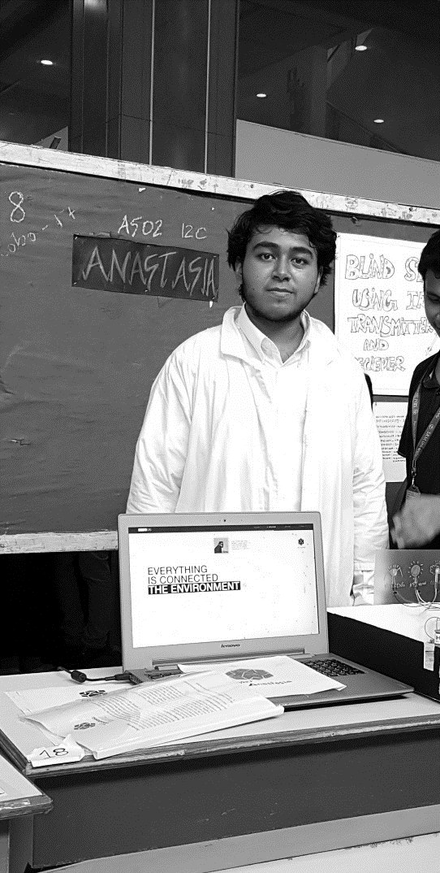

Address M - 803 Bakeri Swara,   
Near ABB campus,  
Makarpura Maneja road,  
Maneja, Vadodara 390013, India.

Contact Number +91 99204 31714   
 e-mail

nishantjana5@gmail.com

Nationality Indian

Date of birth 25th November, 1999

# Affiliations

Primary Undergraduate Student, 2017-2021  
SRM Institute of Science and Technology, Kattankulathur, Chennai

Additional User-Developer, TOPAS MC, a monte-carlo simulation toolkit based on Geant4  
 A 529-member group (global) of medical physicists and clinical experts.

# Research Exp.

Position Research student; (visiting) Dec 2019 - present

Guide Dr. Sheeba Vasu, Behavioural and Neurogenetics Laboratory, JNCASR, India

Area of Research Redox Rhythms in circadian pacemaker neurons (Glutathione and Peroxiredoxin)

Redox state mapping in-vivo snapshots and Ex-Vivo CNS cultures

Position Research student; May 2019 – present.

Guide Dr. S. Sahabudeen, Department of Biotechnology, SRM IST, Chennai, India

Area of Research BPA induced Autism Spectrum Disorder model in Drosophila

# Education

Degree Pursued Bachelors of Technology, Biotechnology; (2017-2021)

Institution SRM Institute of Science and Technology, Kattankulathur, Chennai, India.

12th AISSCE 92% PCM-B(E), 2017

Institution R.N. Podar School, Affiliated to CBSE, Mumbai, India

10th AISSE 9.4 CGPA, 2015

Institution R. N. Podar School, Affiliated to CBSE, Mumbai, India

# Conferences Attended

JAN 2020 APDRC5 – Asia Pacific Drosophila Research Conference 5 (to attend)

poster: “Comprehensive study on the Bisphenol-A induced Drosophila model for Autism Spectrum Disorders with co-treatment by Cerium oxide Nanoparticles and U0126 MAP Kinase inhibitor: genotoxicity, oxidative stress, apoptosis and behavioural irregularities.”

FEB 2019 Accelerating Biology, 2019. BRAF – CDAC, IISER-Pune.

Notable Events Presented Poster on “Computing Machinery and Evolutionary Survival”

Met Joseph Perl, Creator-developer of TOPAS MC, currently part of the project.

*Curriculum Vitæ*

# 

# Computer Skills

Operating Systems Pop!_OS 20.04 on Linux 5.04 Kernel (preferred), Windows10.

Programming Languages Python (****) (Foobar lvl 3 completed)(started learning: June 2020)

MATLAB (****)

R (***)

**Communication Skills**

Languages in which fluent English, Hindi, Bengali.

# Cultural Exposure

# Cities lived in Mumbai (Khar,12 years); Hyderabad (Banjara Hills,1 year); Delhi (GreenPark,2years)

# Chennai (SRM, 3 years).

Cities (<year) Bangalore (JNCASR, Jakkur), Ahmedabad (born in city, Vastrapur), Vadodara

# 

# Summer Schools NeuroMatch Academy (2020) – Summer School on Computational Neuroscience

# - Project on Information loss in engaged brain states.

# ChronoSchool (2020) – Society for Research on Biological Rhythms

# - Rhythm Analysis from Android Activity data

# (for data acquired from myactivity.google.com)

# 

# Online Courses Computational Neuroscience – University of Washington, Coursera

# (completed and ongoing) Google IT Automation with Python (5 part + project) – Google, Coursera

# Deep Learning Specialisation (5 part) – deeplearning.ai, Coursera

# AWS computer vision: Getting started with GluonCV, Coursera

# Computer Science: Algorithms, Theory and Machines, Princeton, Coursera.

# Computer Vision Basics – SUNY, UB, Coursera

# Introduction to Programming in MATLAB – Vanderbilt Univesity, Coursera

# Welcome to Game Theory – University of Tokyo, Coursera

# Statistics with R (5 part + Project) – Duke University, Coursera

# Experimentation for Improvement – McMaster Univeristy, Coursera

# Systems Biology and Biotechnology (5 part + project) – Icahn centre, Coursera

# Circaidan Rhythms: How Rhythms Structure Life – LMU Munich, Coursera

# Visual Perception and the Brain – Duke University, Coursersa

# Medical Neuroscience – Duke University, Coursera

# Bayesian Statistics: From concept to data analysis, UC Santa cruz, Coursera.

# Practical Data Science with MATLAB – Mathworks, Coursera.

# 

# Research Interests

* Clock control on cognitive activity
* Redox state as read-outs for membrane excitability
* Masking effects: calcium inactivity vs redox state
* Neural circuits and roles in specific activity
* Fly behavior: movement and environment model
* Survival associated evolutionary origin of neural circuits

**Career Interest**

**and Motivation** I am a computer nerd fascinated by the way nature shapes machines that compute

with far more complexity, speed an efficiency than has ever been made possible . in-silico. In order to study that, I chose to first study Biology (Thence Biotech in

my bachelors) and caught up on the computer sciences from all the wonderful

. resources online. I am working towards a career in the intersection of these two

. amazing fields, looking for opportunities that let me use my understanding of . . neuroscience to augment new ways of computing in machines.